Generative AI

**#1 What is Generative Ai?**  
-> A set of machine learning techniques that enable computers to generate new data based on existing input.  
Can be used to create anything from images and music to text and even 3D models.

Generative artificial intelligence (generative AI) is a branch of machine learning (ML). It is concerned with the development of algorithms that can create natural language text, images, code, audio, or videos based on user input. Generative AI has numerous applications in various industries, such as media, entertainment, healthcare, and finance

How does Generative Ai actually work?  
-> An image generation model analyses thousands of pictures of flowers to learn common features such as petal shape, colour, and texture.  
Once the model has learned these patterns, it can generate entirely new images that resemble real flowers but are not  
exact copies of any single image.  
  
Learn more @  
<https://www.arunapattam.com>  
<https://www.youtube.com/c/ArunaPattam>  
  
**#2** [**Top 5 Classifications of Generative AI**](https://degreed.com/articles/top-5-classifications-of-generative-ai?d=37642616&inputtype=article&hosted=true&hosted=true&contentSource=&newWindow=true):  
Generative AI is a field of AI that focuses on creating new content such as images, text, videos or code  
Here are the Top 5 Classification of Generative AI:

1) Image Generation:  
 Creating a new image using existing once as basis   
 Ex: Generating realistic-looking product photos for e-commerce websites.

2) Text Generation:  
 Generating new text based on existing text  
 Ex: Creating personalised messages for customers.

3) Video Generation:  
 Creating new videos based on the existing ones.  
 Ex: Generating virtual tours of properties for real estate businesses.

4) Code Generation:  
 Creating a new code or modifying a existing code based on specific criteria.  
 Ex: Automating software development tasks such as code generation.

5) Creative Applications:  
 Using generative AI to help designers create new designs based on specific criteria or preferences.  
 Ex: Designing furniture layouts for interior decorators.

**#3 Applications of Generative AI in five industries:**1) Banking:   
 Chatbots powered by Generative AI can handle routine customer inquiries, such as balance inquiries and transaction history, without the need for human intervention.  
 By automating these processes, banks can improve response times and reduce costs associated with staffing call centres.

2) Retail:  
 Generative AI can generate product photography and virtual fashion models that showcase their items in a realistic and engaging way. This technology allows retailers to create high-quality visual content without the need for expensive photoshoots or models.

3) Telecom:  
 Generative AI to create chatbots that can handle a wide range of customer inquiries and issues. These chatbots can provide 24/7 support and are capable of handling multiple conversations at once, reducing wait times for customers.

4) HealthCare:  
 Generative AI algorithms can analyse vast amounts of data from various sources, including medical records, genetic  
information, and clinical research studies to create a personalized treatment plan that is tailored to each individual's unique needs.

5) Manufacturing:  
 Generative AI to optimize the design of a specific component by analysing various design parameters such as size, weight, and material properties. The algorithm can then generate multiple design options that meet these criteria while also considering other factors such as cost and manufacturability.

**#4 Generative AI categories:**Generative AI is a powerful technology that enables machines to create new content or transform existing data in various  
formats, sparking innovation and creativity.

Generative AI Categories Let's dive into its main categories, based on input and generated output formats.

1) Text-to-Image:  
 Here, AI transforms a text description into a visual representation.  
EG:  
Imagine providing a description like "a red ball on green grass," and the AI creates an image matching that description.  
Models:  
Open AI - DALL-E 2  
Google - Imagen, Muse

2) Text-to-3D:  
 Here, AI translates a textual description into a detailed three-dimensional model.  
EG: Provide a description like "a modern skyscraper with glass windows," and the AI generates a 3D representation of that building.   
Models:  
Google - Dream fusion,  
Nvidia - Magic3D

3) Image-to-Text:  
 Here, AI analyses a visual representation and generates a textual description.  
EG: Provide an image of a red ball on green grass, and the AI creates a caption or tags describing the scene.  
Models:  
DeepMind - Flamingo,  
Microsoft – Visual GPT

4) Text-to-Video:  
 Here, AI converts a textual narrative into a dynamic video representation.  
EG: Provide a description like "a kitten playing with a ball of yarn," and the AI creates a video that showcases the playful interaction.  
Models:  
Google - Phenaki,  
Runaway

5) Text-to-Audio:  
 Here, AI converts a text description into an auditory experience.  
EG: Provide a text like "the soothing sound of waves crashing on the beach," and the AI generates an audio clip that captures the essence of the scene.  
Models:  
Google - AudioLM  
Open AI – Whisper

6) Text-to-Text:  
 Here, AI processes a text input and generates new text based on that input.  
EG: Provide a description like "a red ball on green grass," and the AI creates a related sentence such as “A vibrant red ball sits atop lush green grass."  
Models:  
OpenAI - ChatGPT  
Notion – NotionAI

7) Text-to-code:  
 Here, AI translates a text description into functional code.  
EG: Provide a description like "create a program to calculate the area of a circle," and the AI generates code that performs the specified task.  
Models:  
OpenAI - Codex  
Google – Alphacode

8) Text-to-Science:  
 Here, AI takes a text description and generates a scientific explanation or hypothesis.  
EG: Provide a description like "the process of photosynthesis in plants," and the AI creates a detailed explanation of how plants convert sunlight into energy.  
Models:  
Meta - Galactica  
Google – Minerva

**chatGPT will introduce a on November 2022  
In 2023 Google release a GenAI called Bard  
Microsoft also introduced a Bing search engine which added generative search experience.**

**What is ML?**

To better understand generative AI, it’s important to understand ML. You might be asking yourself, “how do machines learn?” In essence, ML is training a computer to recognize patterns in historical data to make predictions on new data. These predictions are then used to take business actions.  
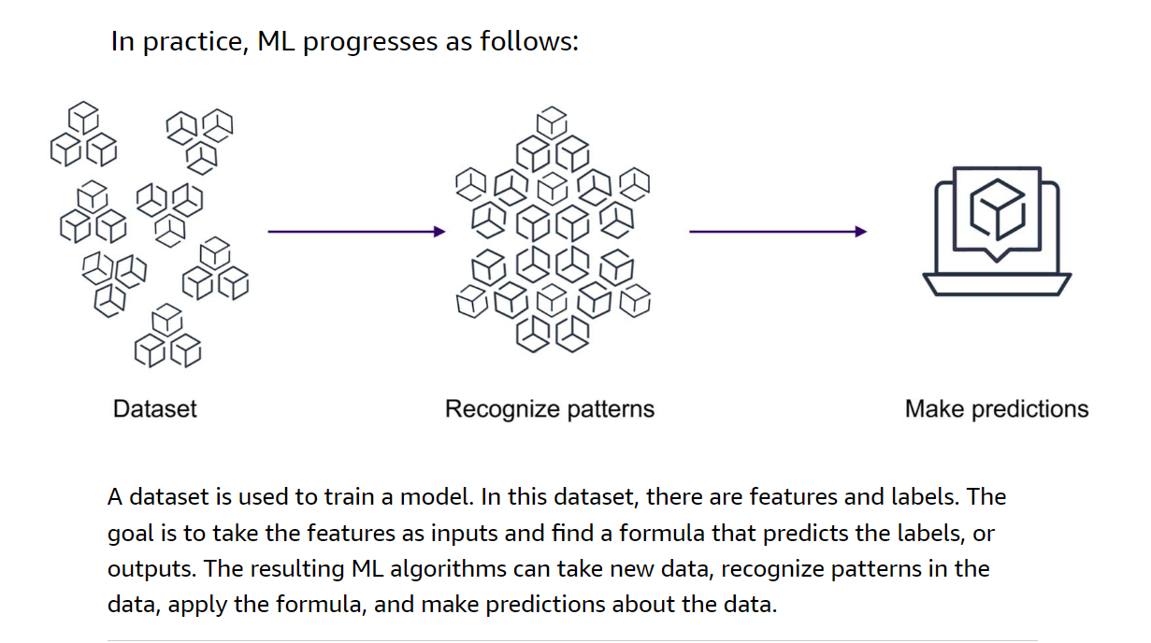

**Understanding the difference between generative AI and traditional ML**

Generative AI is a subset of deep learning because it can adapt models built using deep learning, but without retraining or fine tuning. Deep learning uses the concept of neurons and synapses similar to how our brain is wired. An example of a deep learning application is Amazon Rekognition which can analyze millions of images, streaming and stored videos within seconds. Amazon CodeWhisperer, an example of a generative AI application, can generate code suggestions in real time based on your comments and existing code.

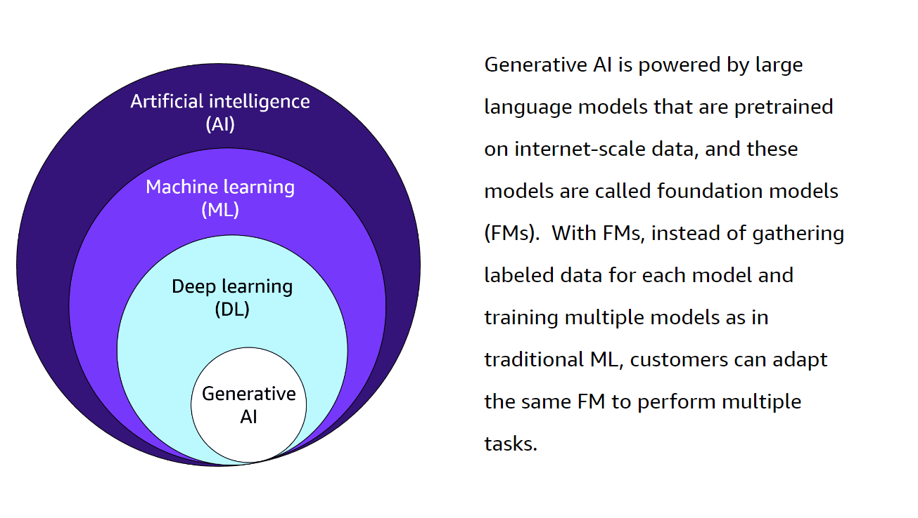  
**What are customers saying about CodeWhisperer?**

Accenture uses CodeWhisperer to improve developer productivity, including for developer onboarding, writing boilerplate code, using unfamiliar languages, and detecting security vulnerabilities. The following quote from Balakrishnan Viswanathan, Senior Manager, Tech Architecture at Accenture, highlights the impact ChodeWhisperer has had on the company's business.  
**Improve business operations**

Finally, you can use generative AI to improve business operations with intelligent document processing, maintenance assistants, quality control and visual inspection, and synthetic training data generation.  
**How Amazon uses generative AI**

One of the ways Amazon is using generative AI is with the Create With Alexa feature. Create With Alexa uses advances in conversational and generative AI to empower young storytellers to build unique stories with a narrative arc, colorful graphics, and fun, complementary background music. The animated stories then come to life on the screen of Amazon Echo Show devices.

To build these stories, Alexa researchers created several different content generators using generative AI. To learn more about the Create With Alexa feature, choose the   
generative AI use cases  
Generative AI contributes to healthcare in the following ways:

* **AWS HealthScribe:** empowers healthcare software vendors to build clinical applications that automatically generate clinical notes by analyzing patient-clinician conversations.
* **Personalized medicine:** By generating treatment plans based on a patient's specific genetic makeup, lifestyle, and disease progression, AI can contribute to more effective, personalized care.
* **Medical imaging:**AI can enhance, reconstruct, or even generate medical images, like X-rays, MRIs, or CT scans, which can aid in better diagnosis.

Generative AI contributes to life sciences in the following ways:

* **Drug discovery:** AI can generate new potential molecular structures for drugs, accelerating the process of drug discovery and reducing costs.
* **Protein folding prediction:** AI can predict the 3D structures of proteins based on their amino acid sequence, which is crucial for understanding diseases and developing new therapies.
* **Synthetic biology:**AI can generate designs for synthetic biological systems, such as engineered organisms or biological circuits.

Generative AI contributes to financial services in the following ways:

* **Fraud detection mechanisms:** Generative AI can help create synthetic datasets to improve AI/ML systems by simulating various money-laundering patterns.
* **Portfolio management:** Generative AI can simulate various market scenarios and help in the creation and management of robust investment portfolios.
* **Debt collection:** AI can generate the most effective communication and negotiation strategies for debt collection, increasing the rate of successful collections.

Across the banking industry, for example, AI technology can deliver value equal to an additional $200-$340 billion annually if the use cases above are fully implemented (McKinsey Report 2023).

Generative AI contributes to manufacturing in the following ways:

* **Product design:** Generative AI can be used to create new product designs based on set parameters and constraints. It can generate multiple design options and optimize for factors like cost, materials, performance, and so forth.
* **Process optimization:**AI can generate the most efficient production processes by modeling different scenarios and optimizing for variables such as cost, time, resource usage, and so forth.
* **Preventative maintenance:**By analyzing historical production data, AI can predict maintenance schedules that will provide the most efficient machine outputs and reduce downtimes.
* **Material science:**AI can help generate new material compositions with desired properties

Generative AI contributes to retail in the following ways:

* **Pricing optimization:**Generative AI can model different pricing scenarios to determine optimal pricing strategies that maximize profits.
* **Virtual try-ons:** AI can generate virtual models of customers for virtual try-ons, improving the online shopping experience.
* **Store layout optimization:** AI can generate the most efficient store layouts to improve the customer shopping experience and boost sales.
* **Product review summaries:** AI can generate review summaries for products so consumers can quickly find pertinent information.

In retail and consumer packaged goods, the potential generative AI impact is significant at $400 billion to $660 billion a year. (McKinsey Report 2023).

Generative AI contributes to media and entertainment in the following ways:

* **Content generation:**Generative AI can be used to create scripts, dialogues, or even complete stories for films, TV shows, and games.
* **Virtual reality:**Generative AI can create immersive and interactive virtual environments for games or simulations.
* **News generation:** AI can generate news articles or summaries based on raw data or events.

**What are some possible risks with generative AI?**

Ease of use also brings possible risks. For more information review the following three risks.  
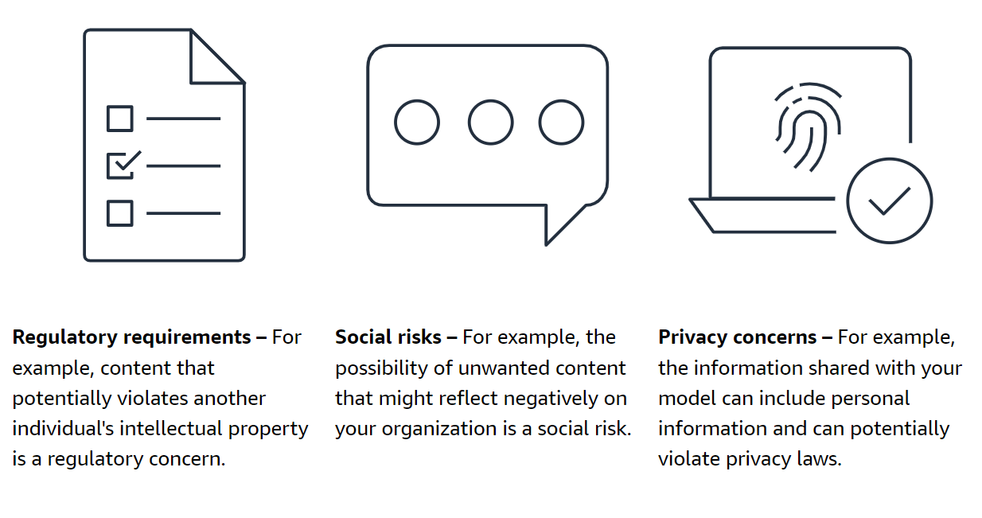

**What are some benefits of generative AI?**

The benefits businesses can realize from generative AI are just now coming to the market. For more information review the following four benefits.

